SOLUTION TO PROBLEM
PROGRAMME: DIT
YEAR/SEM: YEAR 1 SEM 2
PROBLEM NAME: LAB BOOK
SUPERVISOR: OPOLOT JUSTIN

STUDENT DETAILS:
NAME OF STUDENT | NAMUSOKE JOAN
ROLL NUMBER | 012240030

Contents
QUESTION ONE(OOP BASIC) 3
QUESTION TWO (OOP BASIC) 11
QUESTION THREE (INHERITANCE) 17
QUESTION FOUR(POLYMORPHISM) 21
QUESTION FIVE (FILE HANDLING) 26
QUESTION SIX (EXCEPTION HANDLING) 30
QUESTION SEVEN (ABSTRACTION) 34
QUESTION EIGHT(INHERITANCE) 40
QUESTION NINE(ENCAPSULATION) 44
QUESTION TEN(FUNCTIONS) 48

QUESTION ONE(OOP BASIC)
Create a C++ class called Vehicle that has the following properties:
- brand (string)
- model (string)
- year (int)
Implement the following methods:
- A constructor to initialize the vehicle details
- displayDetails method to display the vehicle details
Create two derived classes Car and Truck that inherit from the Vehicle class. The Car class should have an additional property numberOfDoors and the Truck class should have an additional property payloadCapacity. Implement the displayDetails method in both derived classes to display the vehicle details and the additional properties.

1.1 LINES OF CODE & DETAILED EXPLANATIONS
Line Number | Detailed Explanation
#1 | It allows us to work with input and output stream (cin, cout)
#2 | Enables use of the 'string' data type
#3 | A blank line. It’s used to make the code more readable
#4 | It is used to organize the components of the C++ Standard Library and prevent naming conflicts.
#5 | A blank line. It’s used to make the code more readable
#6 | I declared the base class named Vehicle
#7 | Public access specifier with semi columns
#8 | String variables of brand and model
#9 | Int variable of year
#10 | A blank line. It’s used to make the code more readable
#11 | Constructor initializes the object's attributes using passed parameters
#12 | It assigns the value of the parameter a to the member variable brand
#13 | It assigns the value of the parameter b to the member variable model
#14 | It assigns the value of the parameter c to the member variable year
#15 | This is a closing brace that is used to end a constructor
#16 | A blank line. It’s used to make the code more readable
#17 | This line defines a displayeDetails function of Vehicle class and doesn't return anything when executed
#18 | This line prints the text "Brand: " followed by the value stored in the brand variable, then moves to the next line
#19 | This line prints the text "Model: " followed by the value stored in the model variable, then moves to the next line
#20 | This line prints the text "Year: " followed by the value stored in the year variable, then moves to the next line
#21 | This is where the displayDetails() function ends
#22 | This ends the base class known as the vehicle class
#23 | A blank line. It’s used to make the code more readable
#24 | This line defines a new class named Car that inherits from another class called Vehicle
#25 | Public access specifier with semi columns
#26 | This line adds a variable to the Car class to store the number of doors the car has.
#27 | A blank line. It’s used to make the code more readable
#28 | This is the constructor for the Car class.It sets up a Car object with values for brand, model, year from Vehicle class, and numberOfDoors
#29 | This line is inside the Car class constructor. It assigns the value from the constructor's parameter doors to the class's member variable numberOfDoors.
#30 | This is a closing brace that is used to end a constructor
#31 | A blank line. It’s used to make the code more readable
#32 | This line defines a displayeDetails function of Car class and doesn't return anything when executed
#33 | This calls the base class version of displayDetails() to print common info before adding more details specific to the derived class.
#34 | This line displays the text "Number of Doors: " followed by the actual number of doors of the car, then moves to the next line
#35 | This is a closing curly brace that ends the displayeDetails function of Car class
#36 | This line ends derived Car class that is inherited from the Vehicle class
#37 | A blank line. It’s used to make the code more readable
#38 | This line defines a new class named Truck that inherits from another class called Vehicle
#39 | Public access specifier with semi columns
#40 | This line adds a variable to store how much load or weight a truck can carry
#41 | A blank line. It’s used to make the code more readable
#42 | This is the constructor of the Truck class. It sets up a Truckobject with values for brand, model, year from Vehicle class, and payload capacity
#43 | This line assigns the value from the constructor parameter capacity to the class member variable payload Capacity.
#44 | This is a closing curly brace that ends the displayeDetails function of Truck class
#45 | A blank line. It’s used to make the code more readable
#46 | This line starts the displayDetails() function that belongs to a class , the Truck class.
#47 | This line calls the displayDetails() function from the base class Vehicle, even though you're currently inside a derived Truck class
#48 | This line prints the payload capacity of a truck , followed by the word "tons", and then ends the line.
#49 | This is a closing curly brace that ends the displayeDetails function of Truck class
#50 | This line ends derived Truck class that is inherited from the Vehicle class
#51 | A blank line. It’s used to make the code more readable
#52 | This line defines the main function
#53 | This line creates an object named myCar of the class Car and initializes it with specific values.
#54 | This line creates an object named myTruck of the class Truck and initializes it with specific values.
#55 | A blank line. It’s used to make the code more readable
#56 | This line simply prints the heading " Car Details" to t the next line.
#57 | This tells the myCar object to show its details on the screen
#58 | A blank line. It’s used to make the code more readable
#59 | This line simply prints the heading " Truck Details" to t the next line.
#60 | This tells the myTruck object to show its details on the screen
#61 | A blank line. It’s used to make the code more readable
#62 | ends the main function.
#63 | This actually end the main function.

1.2 CODE BLOCKS SCREENSHOTS
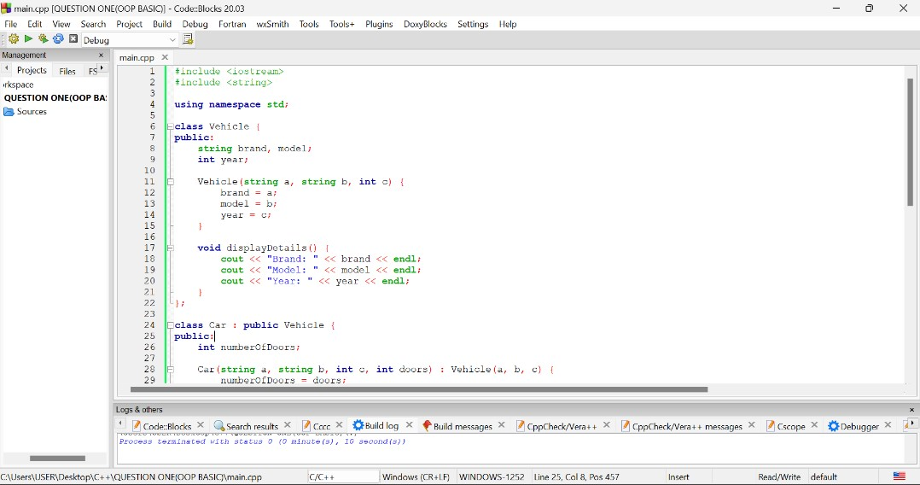
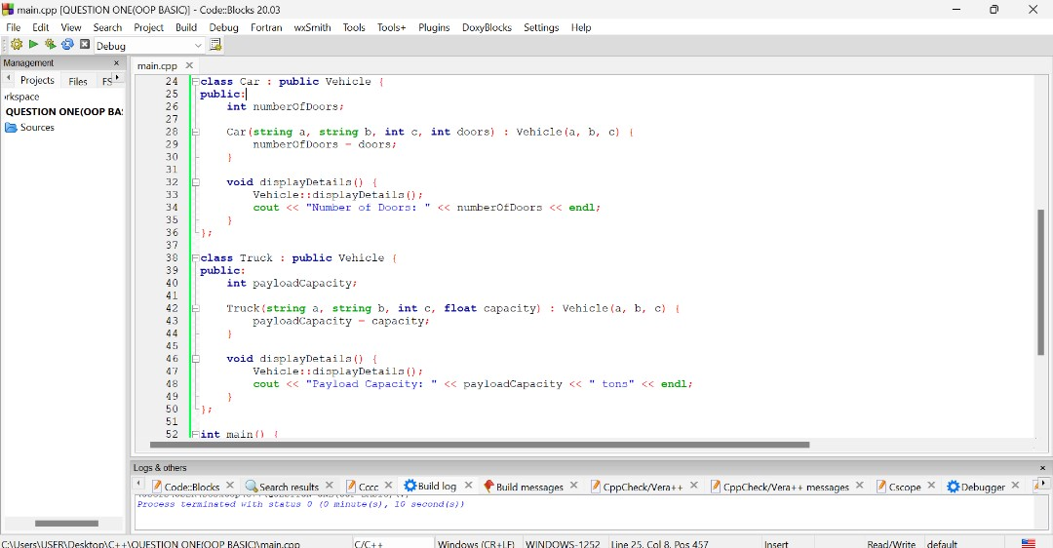
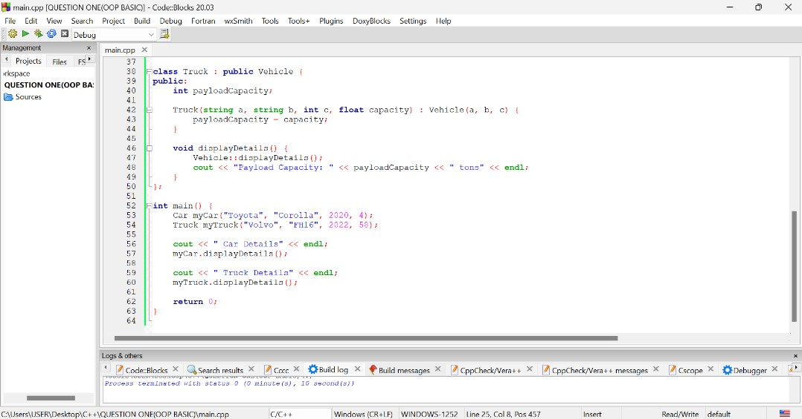

1.3 OUTPUT

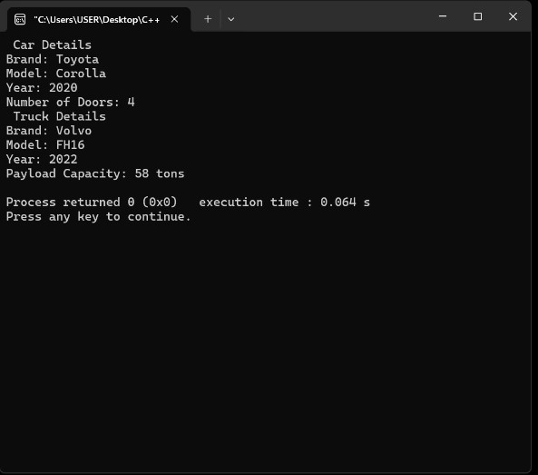

1.4 OUTPUT EXPLANATION
This output shows a formatted display of both the car’s details and the truck’s details.
They share three common pieces of information — brand, model, and year — which are handled by the base class (Vehicle) method.
The specific details unique to each type are printed by their respective derived class methods:
  - numberOfDoors is printed by the Car class.
  - payloadCapacity is printed by the Truck class.
This demonstrates how inheritance lets us reuse common code while allowing each subclass to add its own specific behavior.

QUESTION TWO (OOP BASIC)
Create a C++ class called Date that has the following properties:
  - day (int)
  - month (int)
  - year (int)
Implement the following methods:
- A constructor to initialize the date
- displayDate method to display the date in the format "DD/MM/YYYY"
isLeapYear method to check if the year is a leap year

2.1LINES OF CODE & DETAILED EXPLANATIONS
Line Number | Detailed Explanation
#1 | It allows us to work with input and output stream (cin, cout)
#2 | A blank line. It’s used to make the code more readable
#3 | It is used to organize the components of the C++ Standard Library and prevent naming conflicts.
#4 | This line defines a class named Date
#5 | Public access specifier with semi columns
#6 | This line declares an integer variable of day
#7 | This line declares an integer variable of month
#8 | This line declares an integer variable of year
#9 | A blank line. It’s used to make the code more readable
#10 | This line defines a constructor for the Date class.
#11 | This line assigns the value of the constructor parameter d to the class member variable day.
#12 | This line assigns the value of the constructor parameter m to the class member variable month.
#13 | This line assigns the value of the constructor parameter y to the class member variable year.
#14 | This is a closing brace that is used to end a constructor
#15 | A blank line. It’s used to make the code more readable
#16 | This line defines a member function named displayDate() inside the Date class.
#17 | This line prints the day part of the date in two-digit format. If the day is a single digit, add a 0 in front, then print the day and a slash
#18 | This line prints the month part of the date in two-digit format. If the day is a single digit, add a 0 in front, then print the day and a slash
#19 | This line prints the year part of the date and then moves to the next line.
#20 | This is where the displayDate() function ends
#21 | A blank line. It’s used to make the code more readable
#22 | This function checks whether the stored year is a leap year and returns true or false
#23 | This line checks whether the year is divisible by 400 . It is used as a key condition to determine if it’s a leap year.
#24 | This line ends the function and returns the boolean value true to that this year is a leap year.
#25 | This marks the end of the if statement
#26 | This line checks if the year is divisible by 100 but not by 400 which means it is not a leap year
#27 | This line ends the function and returns the boolean value false showing that the year is not a leap year.
#28 | This marks the end of the else if statement
#29 | This line checks if the year is divisible by 4 but not divisible by 100 or 400 which means it is a leap year
#30 | This line ends the function and returns the boolean value true to that this year is a leap year.
#31 | This marks the end of the else if statement
#32 | In this line if none of the earlier checks for leap year apply, then do this
#33 | This line ends the function and returns false implementing that the year is not a leap year.
#34 | This marks the end of a conditional statement
#35 | This ends the Boolean statement
#36 | A blank line. It’s used to make the code more readable
#37 | This closes the definition of a class
#38 | A blank line. It’s used to make the code more readable
#39 | This line defines the main function
#40 | This line creates an object named today of the Date class and initializes it using the constructor
#41 | A blank line. It’s used to make the code more readable
#42 | This line prints the label “Date: ”
#43 | This line calls the displayDate() function on the today object, which prints the full date in dd/mm/yyyy format.
#44 | A blank line. It’s used to make the code more readable
#45 | Comment to check for leap year
#46 | This is an if condition that checks if the current year today is a leap year
#47 | This line means that if the year is leap then print “This is a leap year”
#48 | This handles the opposite case when the year is not a leap year.
#49 | This line means that if the year is not a leap, then print “This is not a leap year”
#50 | A blank line. It’s used to make the code more readable
#51 | This line ends the main function.
#52 | This actually end the main function.

2.2 CODEBLOCKS SCREENSHOTS

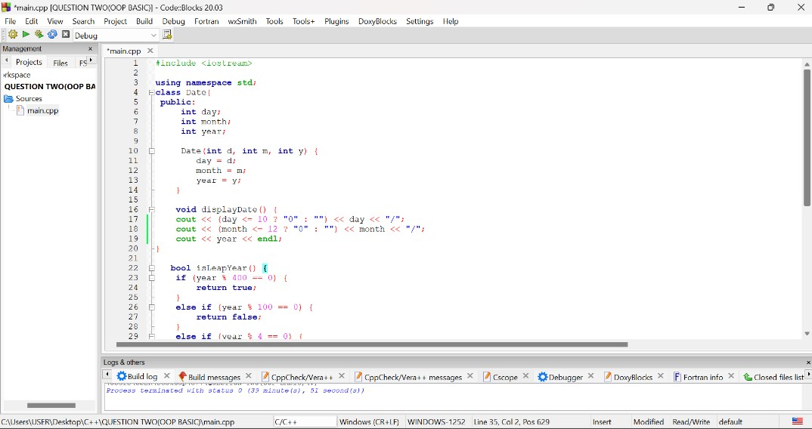
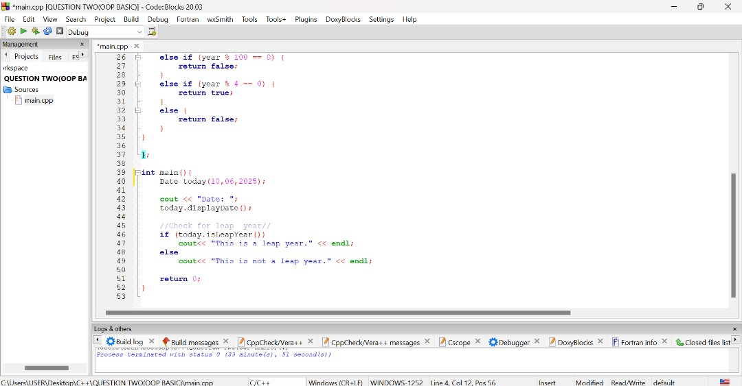

2.3 OUTPUT

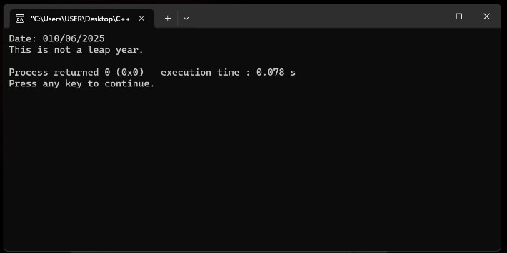

2.4 OUTPUT EXPLANATION
This output displays 10/06/2025, the date using values stored in the object that is; day, month and year.
It also goes a head to display “This is not a leap year.”. This comes from logic that checks if the year 2025 is a leap year (it's not).

QUESTION THREE (INHERITANCE)
Create a C++ program that demonstrates inheritance using a base class Vehicle and derived classes Car and Truck. The Vehicle class should have attributes for brand and model, while the Car and Truck classes should have additional attributes and methods specific to each type of vehicle.

3.1 LINES OF CODE & DETAILED EXPLANATIONS
Line Number | Detailed Explanation
#1 | Includes the input and output stream library
#2 | Includes the string library to use the string data type.
#3 | Uses the standard namespace to avoid writing std:: repeatedly.
#5 | Declares the base class Vehicle.
#6 | Makes the members that follow publicly accessible.
#7 | Declares a string variable to store the vehicle's brand.
#8 | Declares a string variable to store the vehicle's model.
#10 | Defines a constructor to initialize brand and model values.
#12 | Defines a function to display the brand and model of the vehicle.
#13 | Prints the brand and model to the console.
#14 | Ends the displayBasicInfo() method.,
#15 | Ends the Vehicle class definition.
#17 | Declares the Car class, inheriting from Vehicle.
#18 | Makes the following members public.
#19 | Declares an integer to hold the number of passengers in the car.
#21 | Defines the constructor for the Car class.
#22 | Calls the base class constructor and sets the passenger count.
#24 | Defines a method to display full car details.
#25 | Calls the base class method to show brand and model.
#26 | Displays the number of passengers for the car.
#27 | Ends the displayDetails() method for the car.
#28 | Ends the Car class definition.
#30 | Declares the Truck class, inheriting from Vehicle.
#31 | Makes the following members public.
#32 | Declares a double to store the truck’s load capacity (tons).
#34 | Defines the constructor for the Truck class.
#35 | Calls the base class constructor and sets the load capacity.
#37 | Defines a method to display full truck details.
#38 | Calls the base class method to show brand and model.
#39 | Displays the load capacity specific to the truck.
#40 | Ends the displayDetails() method for the truck.
#41 | Ends the Truck class definition.
#43 | Begins the main() function, which is the program's entry point.
#44 | Creates a Car object with sample data.
#45 | Creates a Truck object with sample data.
#47 | Prints a heading before showing car details.
#48 | Calls the Car class method to display its details.
#50 | Prints a heading before showing truck details.
#51 | Calls the Truck class method to display its details.
#53 | Ends the program by returning 0 (success).
#54 | Closes the main() function.

3.2 CODEBLOCKS SCREENSHOTS
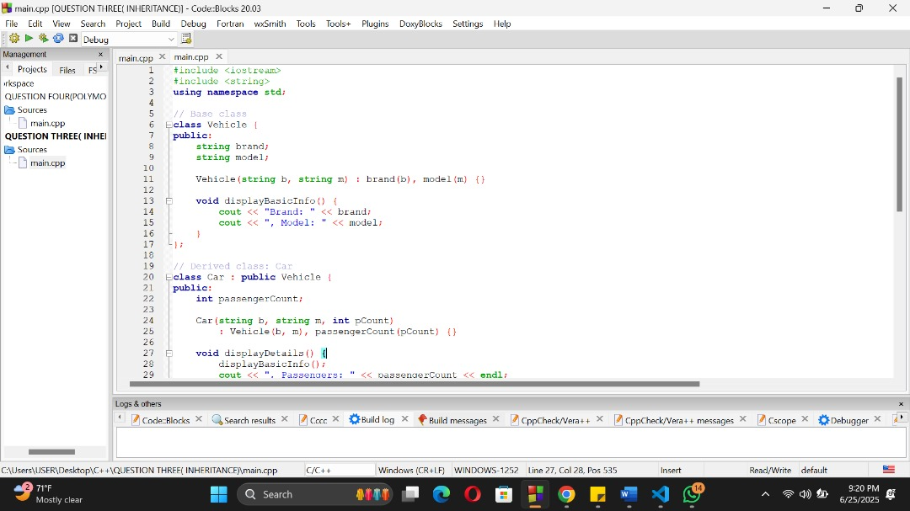

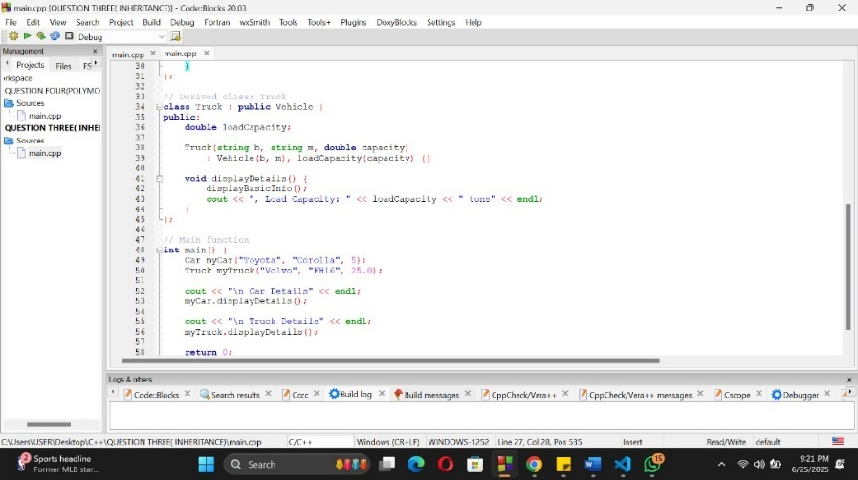

3.3 OUTPUT
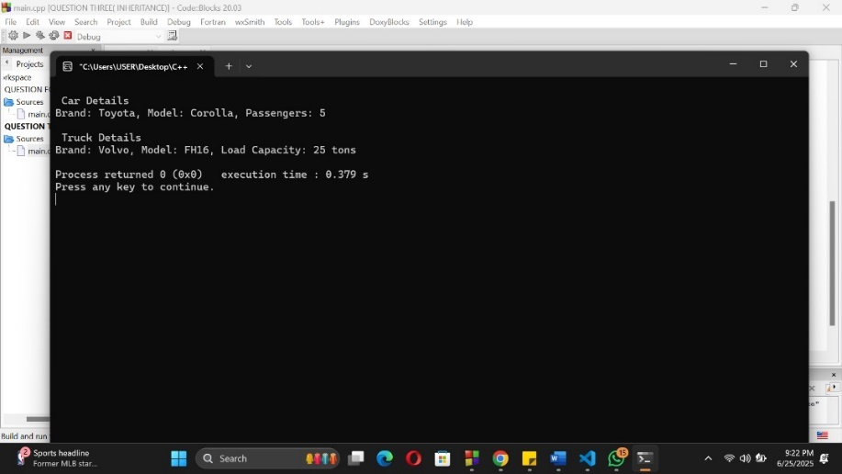

3.4OUTPUT EXPLANATION
The program uses inheritance to share common vehicle data (brand, model) and adds specific data for Car and Truck.
The output shows how each class prints both shared and specific details clearly:
- Car adds number of passengers.
- Truck adds load capacity.

QUESTION FOUR(POLYMORPHISM)
Create a C++ program that demonstrates polymorphism using a base class Employee and derived classes Manager and Developer. The Employee class should have a virtual function displayInfo() that is overridden in each derived class to display specific information about the employee.

4.1 LINES OF CODE & DETAILED EXPLANATIONS
Line Number | Detailed Explanation
#1 | Includes the input and output stream library to enable functions like printing to the console using cout.
#2 | Includes the string library to allow the use of the string data type.
#3 | Uses the standard namespace
#5 | Starts the declaration of the base class named Employee.
#6 | Declares the name attribute to store the employee’s name.
#7 | Declares the id attribute to store the employee’s ID number.
#9 | Begins the constructor of the Employee class to initialize name and ID.
#10 | Assigns the input values to the class attributes name and id.
#13 | Declares the displayInfo method to output employee details.
#14 | Prints the employee’s name to the console.
#15 | Prints the employee’s ID to the console.
#16 | Ends the displayInfo method.
#18 | Starts the declaration of the Manager class, which inherits from Employee.
#19 | Declares the teamCount attribute to store how many teams the manager supervises.
#22 | Begins the constructor of the Manager class.
#23 | Calls the constructor of the base class Employee and sets teamCount.
#26 | Declares a new displayInfo method for the Manager class that overrides the base version.
#27 | Prints the manager’s name.
#28 | Prints the manager’s ID.
#29 | Prints the number of teams managed.
#30 | Ends the displayInfo method for the manager.
#33 | Starts the declaration of the Developer class, which inherits from Employee.
#34 | Declares the language attribute to store the programming language the developer uses.
#37 | Begins the constructor of the Developer class.
#38 | Calls the base class constructor and assigns a value to language.
#41 | Declares a new displayInfo method for the Developer class that overrides the base version.
#42 | Prints the developer’s name.
#43 | Prints the developer’s ID.
#44 | Prints the programming language used by the developer.
#45 | Ends the displayInfo method for the developer.
#48 | Begins the main function — the entry point of the program.
#49 | Dynamically creates a Manager object and stores it in a base class pointer.
#50 | Dynamically creates a Developer object and stores it in a base class pointer.
#52 | Prints a heading for manager information.
#53 | Calls the manager’s displayInfo method via the base pointer.
#55 | Prints a heading for developer information.
#56 | Calls the developer’s displayInfo method via the base pointer.
#59 | Returns 0 to indicate successful program execution.
#60 | Ends the main function.

4.2 CODEBLOCKS SCREENSHOTS

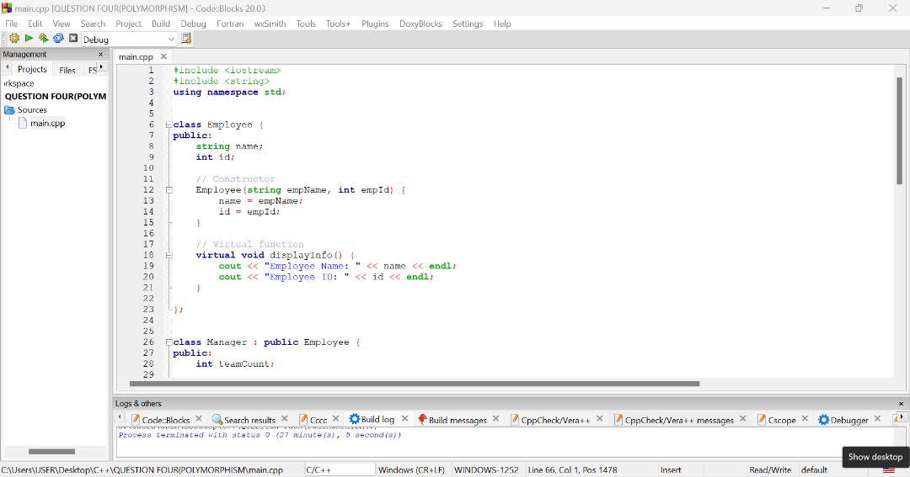
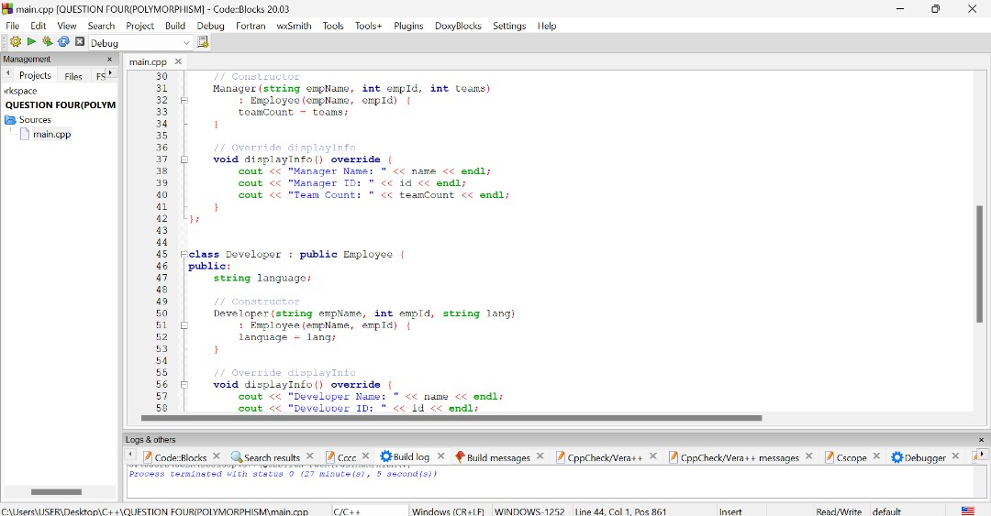
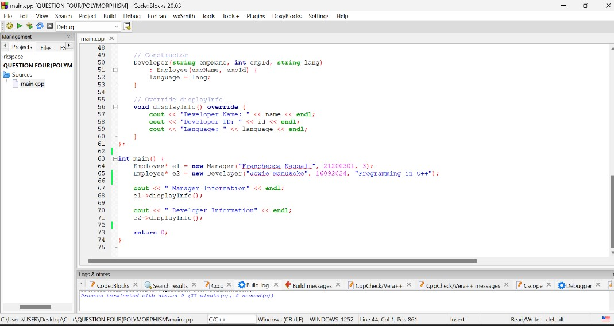

4.3 OUTPUT

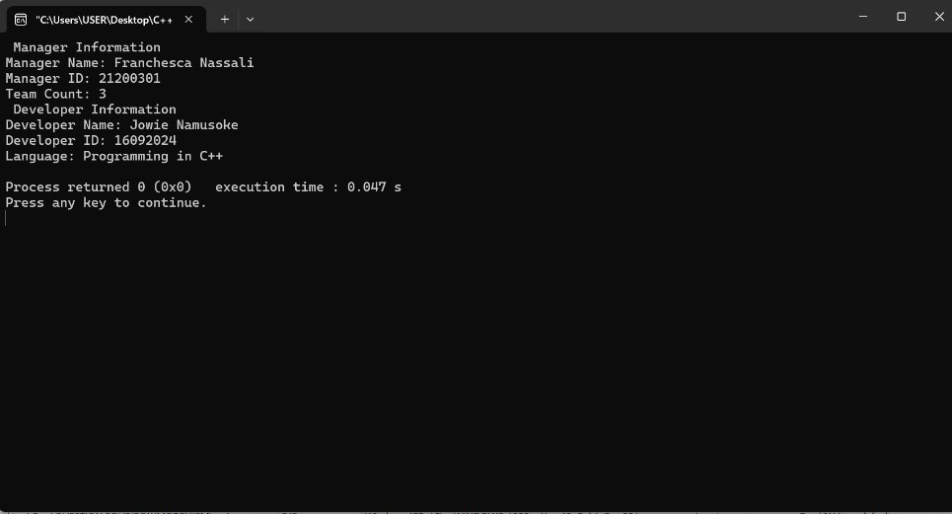

4.4 OUTPUT EXPLANATION
Manager Information
This is a simple heading printed to indicate that the following details belong to a manager.
1. Manager Name: Franchesca Nassali
This line is printed by the displayInfo() function in the Manager class. It displays the name attribute of the manager object that was initialized with "Franchesca Nassali".
2. Manager ID: 21200301
This shows the manager's ID, pulled from the id attribute, which was set to 21200301.
3. Team Count: 3
This shows how many teams the manager oversees, which was passed as 3 during object creation.
Developer Information
This is another heading indicating that the following details are for a developer.
1. Developer Name: Jowie Namusoke
Printed by the Developer class’s displayInfo() function. The name was set as "Jowie Namusoke".
2. Developer ID: 16092024
Shows the developer’s ID number, which was initialized with the value 16092024.
3. Language: Programming in C++
Displays the programming language the developer specializes in. The value "Programming in C++" was passed to the constructor.

QUESTION FIVE (FILE HANDLING)
- Write a C++ program to create a new text file and write a string to it.

5.1 LINES OF CODE & DETAILED EXPLANATIONS
Line Number | Detailed Explanation
#1 | Includes the library for input and output operations (like cout).
#2 | Includes the file stream library needed for reading/writing files.
#3 | Includes the string library so we can use the string data type.
#5 | Begins the main () function where program execution starts.
#7 | Declares a string variable to hold the name of the file to be created.
#10 | Declares and initializes a string variable with two lines of content to be written to the file.
#12 | Creates an output file stream object and associates it with the file name (opens the file).
#14 | Checks if the file was successfully opened for writing.
#16 | If true, writes the content to the file using the file stream.
#18 | Closes the file to save and finish writing.
#20 | Displays a success message to the user on the console.
#22 | If the file could not be opened, displays an error message instead.
#26 | Ends the main() function, returning 0 to signal successful completion.

5.2 CODEBLOCKS SCREENSHOTS
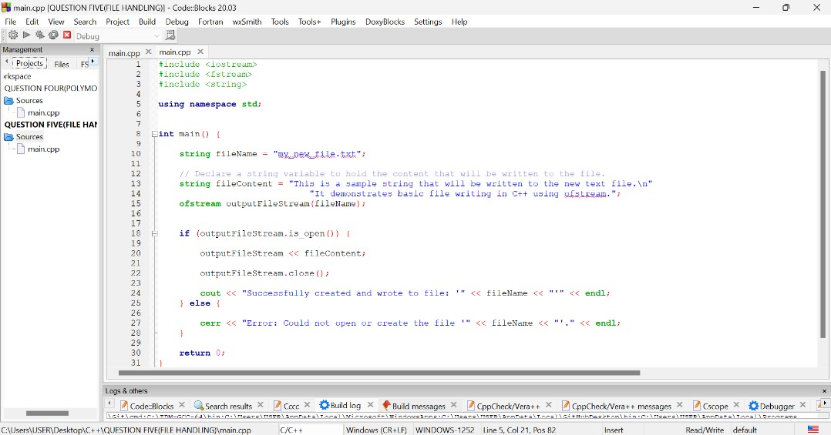

5.3 OUTPUT
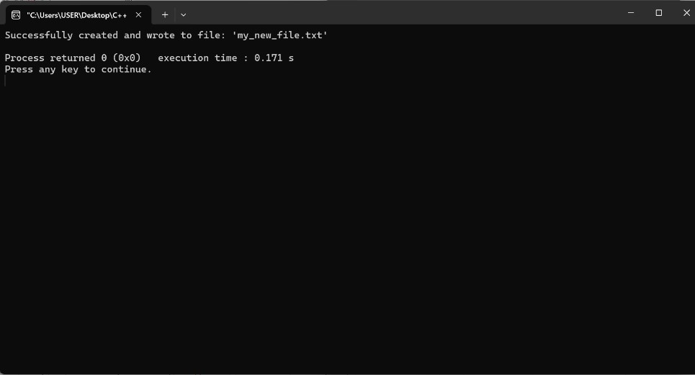

5.4 OUTPUT EXPLANATION
The output shows that the program was able to create a new file and successfully write data into it. The name 'my_new_file.txt' in the output matches the file name specified in the code, which confirms that the correct file was used. This message is printed only when the file opens without any errors, indicating the file-writing process worked as expected.
- Write a C++ program to read a text file and display its contents on the console

5.5 LINES OF CODE & DETAILED EXPLANATIONS

Line Number | Explanation
#1 | Includes the input and output stream library for functions like cout and cin.
#2 | Includes the file stream library for file reading and writing.
#3 | Includes the string library to use the string data type.
#4 | Uses the standard namespace
#6 | Begins the main function where the program execution starts
#8 | Creates and opens a text file for writing.
#10 | Writes a string into the opened text file which is sent into the file
#12 | Closes the file after writing to ensure all content is saved properly.
#14 | Declares a string variable to temporarily hold lines read from the file.
#17 | Opens the text file again, this time for reading.
#20 | Starts a loop to read the file line by line until the end of the file is reached.
#22 | Outputs each line read from the file to the console using cout.
#23 | Ends the while loop.
#25 | Closes the file after reading.
#27 | Ends the program successfully.

5.6 CODEBLOCKS SCREENSHOTS

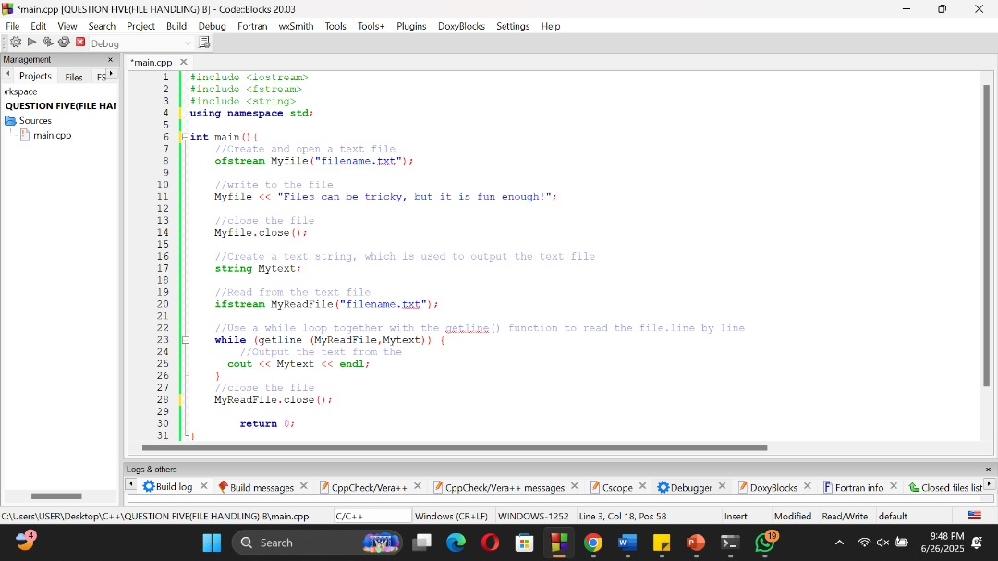

5.7 OUTPUT

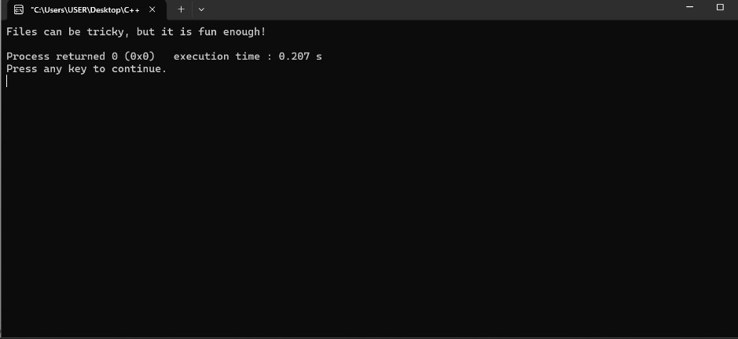

5.8 OUTPUT EXPLANATION
The program first writes a specific sentence to a text file, and then immediately reads that same sentence back from the file and displays it on the screen.

QUESTION SIX (EXCEPTION HANDLING)
Write a C++ program that demonstrates exception handling using a BankAccount class. The program should allow users to deposit and withdraw money from their account. If the user attempts to withdraw more money than is available in the account, the program should throw an exception.

6.1 LINES OF CODE & DETAILED EXPLANATIONS
#include <iostream>
This line tells the compiler to include the Input/Output Stream Library, which allows the use of cout and cin for console input and output.
using namespace std;
This allows direct access to standard library components like cout, cin, endl, etc., without needing the std:: prefix.

class BankAccount { ... };
This defines a class called BankAccount, which models a simple bank account. A class groups data and functions together (Object-Oriented Programming concept).
private: double balance;
This is a private access specifier which means that data in it cannot be accessed directly from outside the class. It stores the current balance of the account.
Public: BankAccount() { balance = 0.0; }
This is the constructor, which is automatically called when an object of BankAccount is created.
It initializes balance to 0.0.
void deposit(double amount)
Public function to add money to the account.
Checks if the amount is negative. If so, throws an invalid_argument exception.In this caes throw is used to signal that an error occurred.
If valid, it adds the amount to balance and displays a message.
void withdraw(double amount)
This is a public function that is used to remove money from the account and also checks if there’s enough money from the account
If not, it throws a runtime_error. However, if enough funds exist, it subtracts the amount from balance and prints the amount withdrawn.
void displayBalance()
This function displays the current balance using cout.
int main()
This is where program execution begins from here.
An object from BankAccount class is created named account and the constructor is automatically called when the object is called.
try { ... } , This block contains code that might cause runtime errors (exceptions). If an error occurs inside the try block, the program jumps to the corresponding catch block.
catch (const exception& e)
This block catches any standard exception (like invalid_argument or runtime_error) that was thrown in the try block.
cout << "Error: " << e.what();
e.what() gives the actual error message that was thrown, which in this case is: Insufficient funds for withdrawal.
return 0;
This ends the program and tells the operating system that the program finished successfully.

6.2 CODEBLOCKS SCREENSHOTS
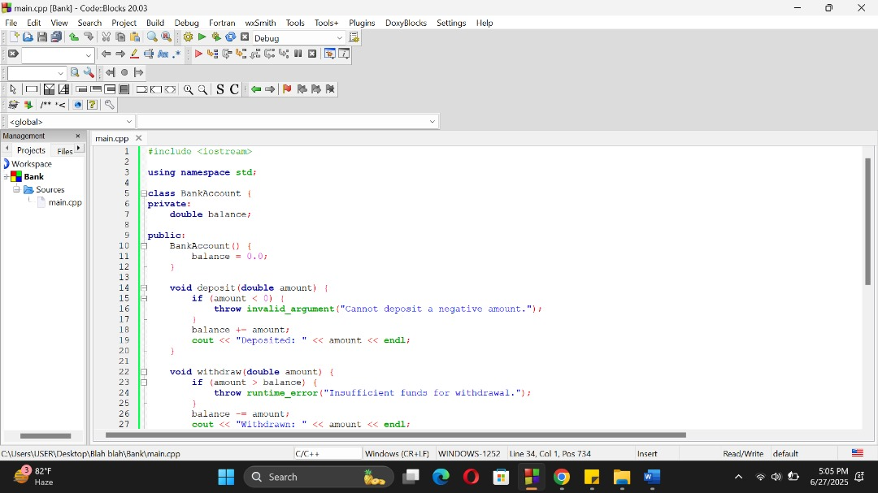

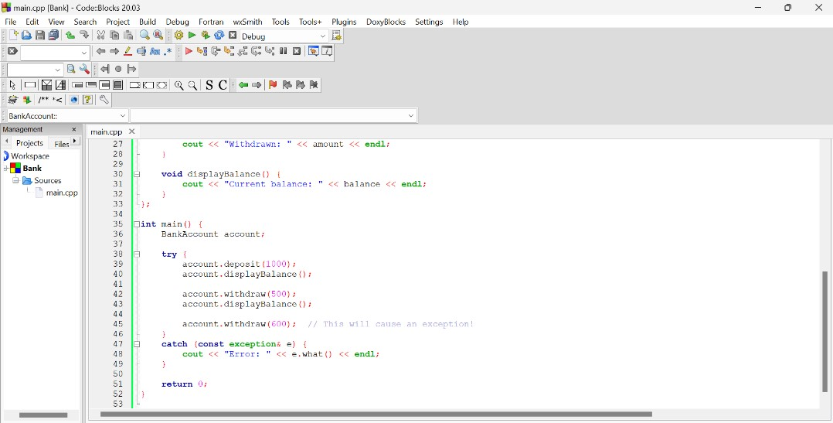

6.3 OUTPUT

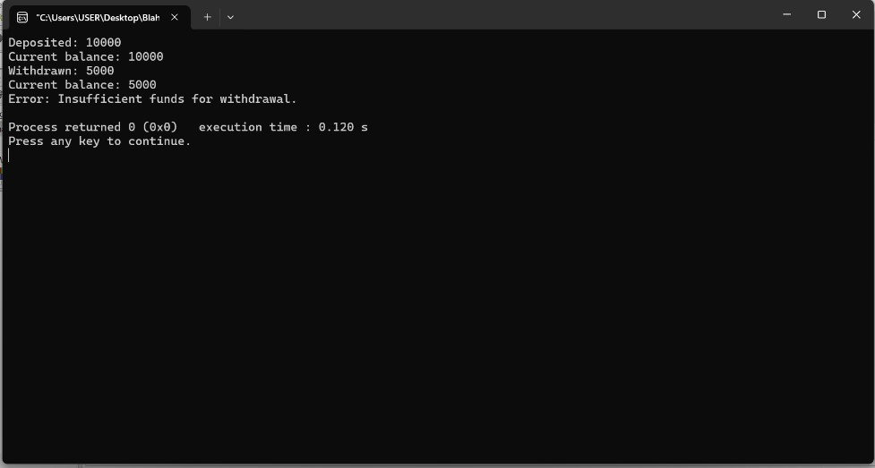

6.4 OUTPUT EXPLANATION
This is a result of a program run where:
- 10,000 was deposited
- 5,000 was successfully withdrawn
- Another withdrawal was attempted that exceeded the remaining balance (likely more than 5,000)

QUESTION SEVEN (ABSTRACTION)
Write a C++ program that demonstrates abstraction using an abstract class Shape with pure virtual functions calculateArea and calculatePerimeter. Implement derived classes Circle, Rectangle, and Triangle that inherit from the Shape class.

7.1 LINES OF CODE & DETAILED EXPLANATIONS
Line Number | Detailed Explanation
#1 | It enables input and out operations to use “cin, cout”
#2 | This library includes math functions
#4 | It means that we can use names for objects and variables from the standard library.
#7 | This line defines an abstract base class named, Shape
#8 | The public specifier makes members accessible to everyone
#9 | This line means that calculate area is an abstract function that must be implemented by any subclass of Shape.
#10 | This line means that calculate perimeter is an abstract function that must be implemented by any subclass of shape
#11 | This line ends the Shape class
#14 | It means create a class called Circle that inherits publicly from the abstract base class Shape
#15 | The private access specifier means data cannot be viewed outside the class
#16 | This holds the circle’s size so it can be used in formulas like area and perimeter
#18 | This means members are accessible from outside the class
#19 | This is the constructor for the Circle class. It's called automatically when a Circle object is created.
#20 | Assign a value to radius in circle class
#21 | Closes the constructor
#23 | Declares a function that returns the area of the circle as a double.
#24 | Calculates the area using the formula π × r² and returns the result.
#25 | This ends the function of calculate area
#27 | Declares a function that returns the perimeter (circumference) of the circle as a double.
#28 | Uses the formula for circumference: 2 × π × r, and returns the result.
#29 | This ends the body of the constructor
#30 | This ends the circle
#33 | Declares a Rectangle class that inherits publicly from the abstract base class Shape.
#34 | variables here are not accessible outside the class
#35 | Declares a variable to store the rectangle’s length.
#36 | Declares a variable to store the rectangle’s width.
#38 | Here members are accessible outside class
#39 | Constructor that accepts two values to initialize length and width
#40 | Assigns the value of parameter l to the member variable length.
#41 | Assigns the value of parameter w to the member variable width.
#42 | Ends the constructor.
#44 | Defines the calculateArea()
#45 | Returns the area of the rectangle using the formula length × width.
#46 | Ends the area function.
#48 | Defines the calculatePerimeter() function (also required by Shape)
#49 | Returns the perimeter using the formula 2 × (length + width).
#50 | Ends the perimeter function.
#51 | Ends the Rectangle class
#54 | Declares a Triangle class that inherits publicly from the abstract class Shape.
#55 | variables here are not directly accessible outside the class.
#56 | Declares variables to store the three sides of the triangle.
#58 | This means that members are accessible from outside class
#59 | Constructor that accepts three side lengths
#60 | Assigns side1 to member variable a
#61 | Assigns side2 to member variable b
#62 | Assigns side3 to member variable c
#63 | This ends the constructor
#65 | Begins the area function implementation.
#66 | Calculates semi-perimeter s using the formula: s = (a + b + c) / 2
#67 | Calculates area using Heron’s formula: √[s(s-a)(s-b)(s-c)].
#68 | Ends the area function.
#70 | Begins the perimeter function implementation.
#71 | Returns the perimeter as the sum of all three sides.
#72 | Returns the perimeter as the sum of all three sides.
#73 | Ends the Triangle class definition.
#75 | This is where execution begins
#76 | Creates a Circle object with radius 5. Calls Circle(double r)
#77 | Creates a Rectangle object with length 4 and width 6.
#79 | Creates a Rectangle object with length 4 and width 6.
#82 | Prints the area of the circle using its calculateArea() method.
#83 | Prints the circle's perimeter.
#85 | Prints the rectangle's perimeter.
#86 | Prints the rectangle's perimeter.
#88 | Prints the triangle's perimeter (sum of sides).
#89 | Prints the triangle's perimeter (sum of sides).
#90 | The program is successfully
#91 | This closes the main function

7.2CODEBLOCKS SCREENSHOTS
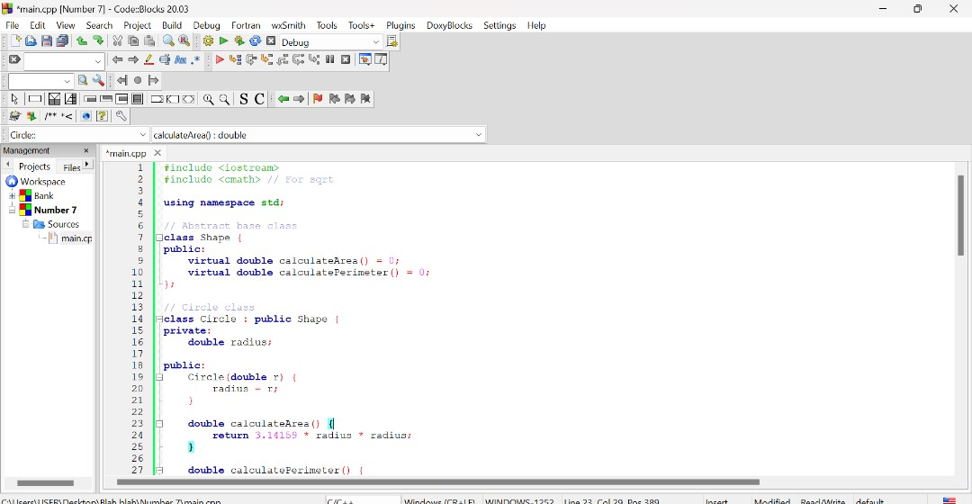
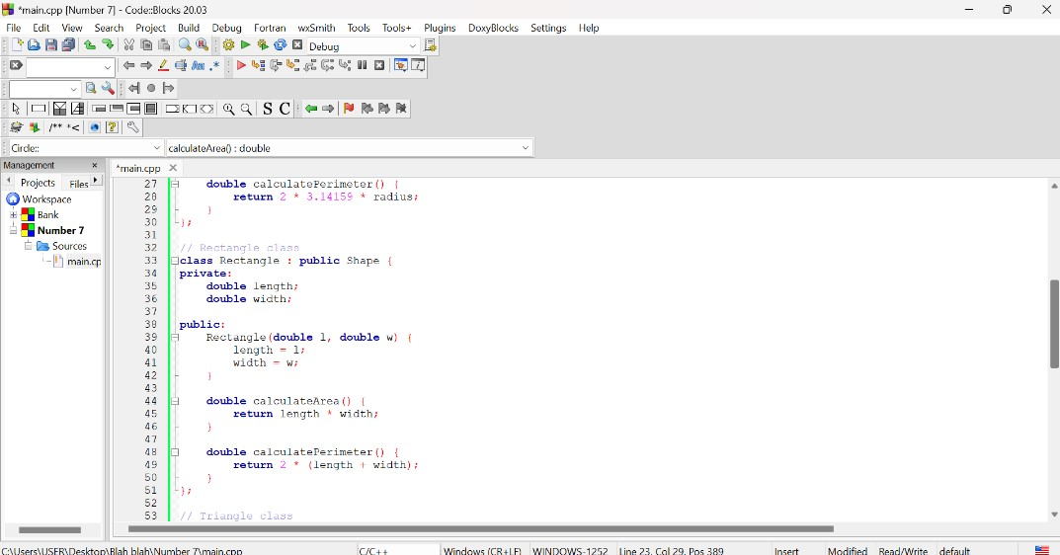
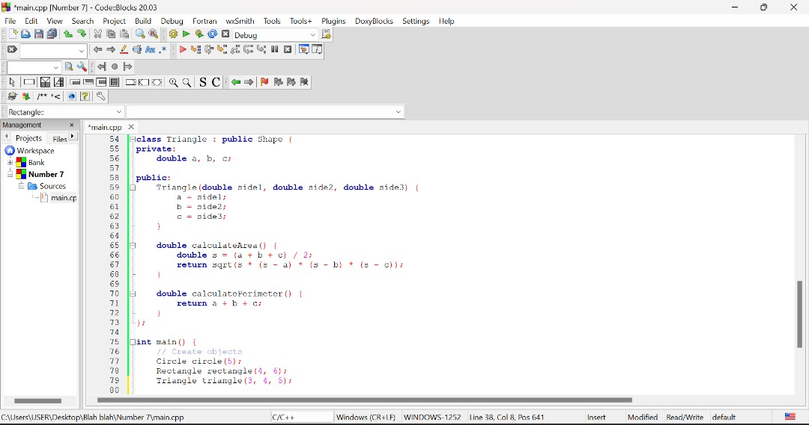
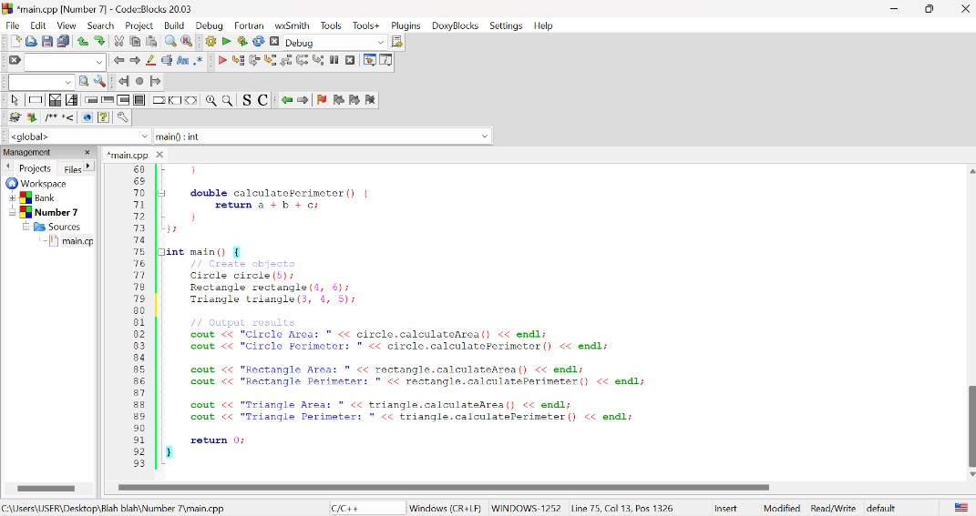

7.3 OUTPUT

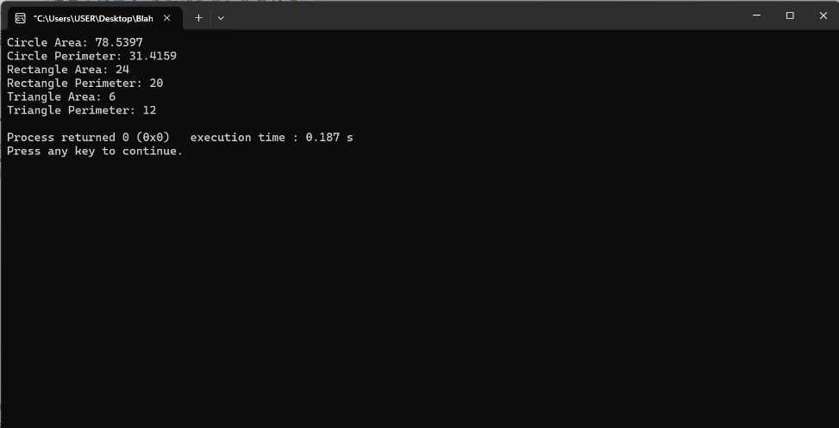

7.4 OUTPUT EXPLANATION
These values result from standard circle formulas using radius 5.
- Formula for Area:
Area=length×width=4×6=24
- Formula for Perimeter:
Perimeter=2×(length+width) =2×(4+6)=20
These are basic rectangle calculations using sides 4 and 6.
- Formula for Perimeter:
Perimeter=a+b+c=3+4+5=12
- Formula for Area:
Semi-perimeter s=3+4+52=6s
This triangle (3, 4, 5) is a right-angled triangle hence the area is 6.

QUESTION EIGHT(INHERITANCE)
Write a C++ program that demonstrates single inheritance using a base class Person and a derived class Employee. The Employee class should inherit the properties and behavior of the Person class and add additional properties and behavior specific to employees

8.1 LINES OF CODE & DETAILED EXPLANATIONS
Line Number | Detailed Explanation
#1 | Includes the input and output stream library
#2 | Includes the string library
#3 | Enables us to us cin and cout without use of std::
#6 | Declares the base class Person.
#7 | Protected specifier
#8 | Declares a variable to store a person’s name
#9 | Declares a variable to store the person's age.
#11 | Public specifier
#12 | Declares a method to set name and age.
#13 | Starts the method body.
#14 | Assigns the parameter n to the class member name.
#15 | Assigns the parameter a to the class member age
#17 | Ends the setPersonDetails() method.
#18 | Declares a method to print the name and age.
#19 | Starts the method body
#20 | Ends the displayPersonDetails() method.
#21 | Ends the Person class.
#24 | Declares the Employee class, derived from Person.
#25 | Private specifier
#26 | Declares a variable for the employee's ID.
#27 | Declares a variable for the employee's ID.
#29 | Members here can be accessed from outside the class.
#30 | Declares a method to set employee-specific details.
#31 | Assigns the value of id to the class variable employeeID.
#32 | Assigns dept to the department variable.
#33 | Ends the setEmployeeDetails() method.
#35 | Declares a method to display all details.
#36 | Calls the base class method to print name and age.
#37 | Prints the employee ID.
#38 | Prints the department name.
#39 | Ends the displayEmployeeDetails() method.
#40 | Ends the Employee class.
#42 | Entry point of the program.
#43 | Creates an Employee object named emp.
#46 | Sets name and age using base class method.
#47 | Sets employee ID and department using derived class method.
#50 | Prints a title heading
#51 | Displays all employee and personal info.
#53 | Exits the program successfully.
#54 | Ends the main() function.

8.2 CODEBLOCKS SCREENSHOTS
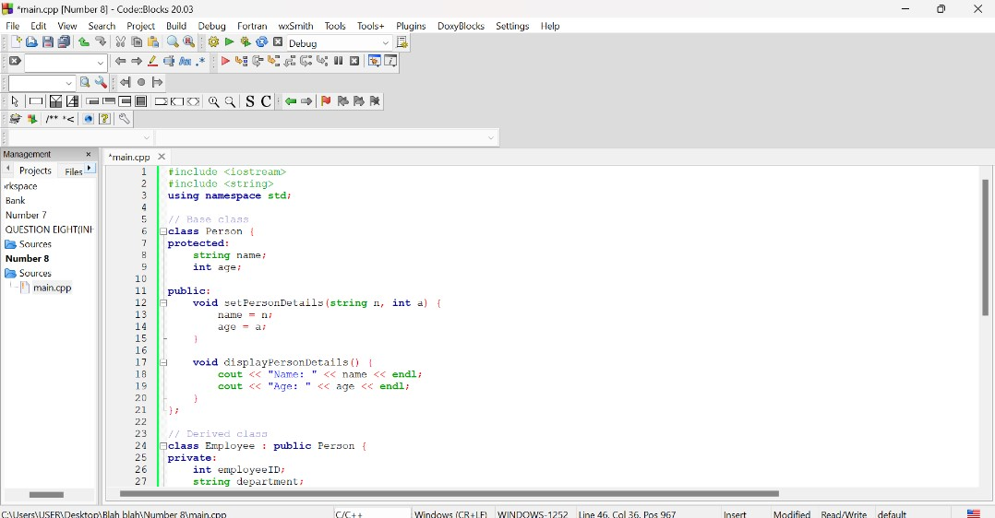
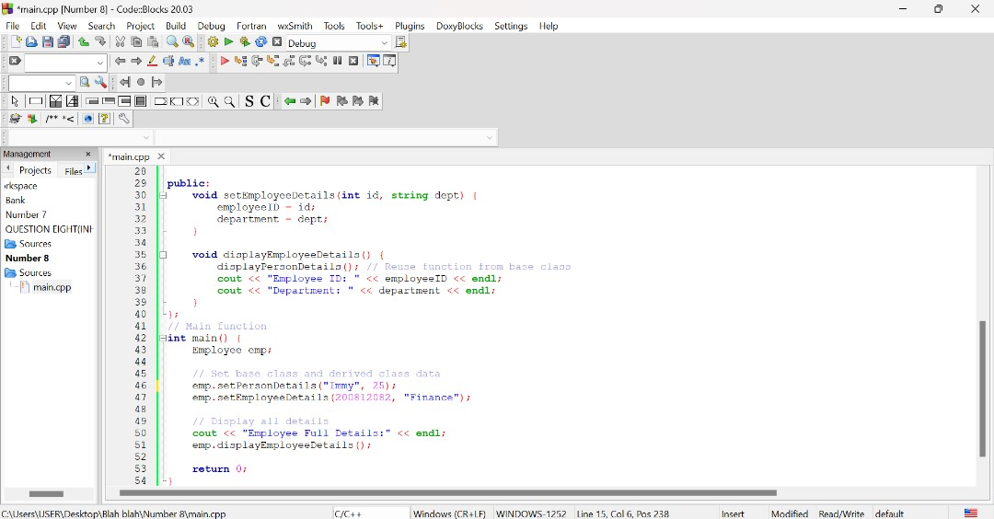

OUTPUT
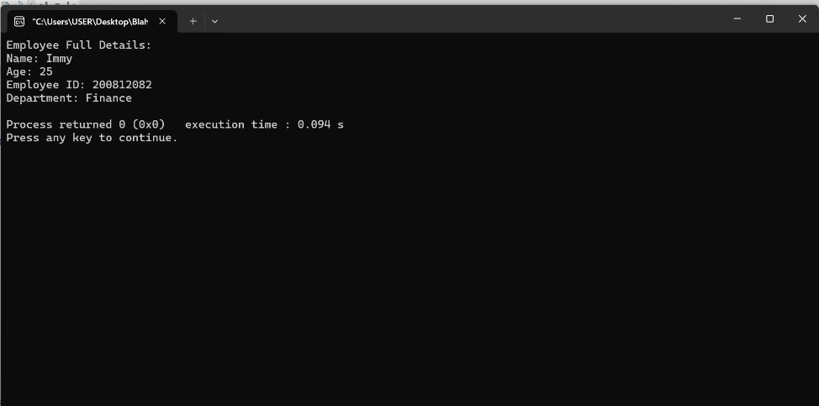

8.4 OUTPUT EXPLANATION
The above output demonstrates that the Employee class inherited details from the Person class, the derived class added its own details (ID and department) and both base and derived class functions were successfully used.

QUESTION NINE(ENCAPSULATION)
Create a BankAccount class that demonstrates encapsulation by hiding the internal state of the account and providing controlled access to it through public member functions.

Requirements
- The BankAccount class should have private data members for account number and balance.
- Implement a constructor to initialize the account number and balance.
- Provide public member functions to deposit and withdraw money from the account.

9.1 LINES OF CODE & DETAILED EXPLANATIONS
1. Private Data Members
These variables are private, meaning they cannot be accessed or modified directly from outside the class. This enforces encapsulation, a fundamental concept in object-oriented programming, which hides the internal state of the object and restricts direct access. By doing so, it helps protect data integrity by allowing controlled access only through public methods.
2. Setter Methods
These methods allow you to safely set the values of private data members. The setAccountNumber method simply assigns the account number, while setBalance includes an important validation check: it ensures the balance is never set to a negative number, and if a negative amount is passed, it prints an error message instead of changing the balance. This validation helps prevent the program from entering an invalid or inconsistent state.
3. Getter Methods
These methods provide read-only access to private data members, allowing other parts of the program to retrieve the current account number and balance without modifying them. This approach preserves the principle of encapsulation by controlling how data is exposed and protecting it from unintended changes.
  - Deposit Method
This method adds money to the account balance by first checking that the deposit amount is positive. If the amount is valid, it increases the balance and prints a confirmation message. If the amount is zero or negative, it prints an error message without changing the balance. This validation protects the data and ensures the program follows realistic banking rules
5. Withdraw Method
This method subtracts money from the account balance, validating two key conditions before proceeding: the amount must be positive, and it must not exceed the current balance (to prevent overdraft). If these conditions are met, the balance is reduced accordingly and a confirmation message is printed. Otherwise, an error message is displayed, and the balance remains unchanged. This approach safeguards the account from going negative, thereby maintaining data integrity.
6. Use of the Class in main()
An object myAccount is created from the BankAccount class, where the account number and initial balance are set using setter methods. Deposit and withdrawal operations are then performed with built-in validation and feedback to ensure correctness. Finally, the program displays the account number and current balance, demonstrating how encapsulation enables safe and meaningful interaction with the object’s data.

9.2 CODEBLOCKS SCREENSHOTS

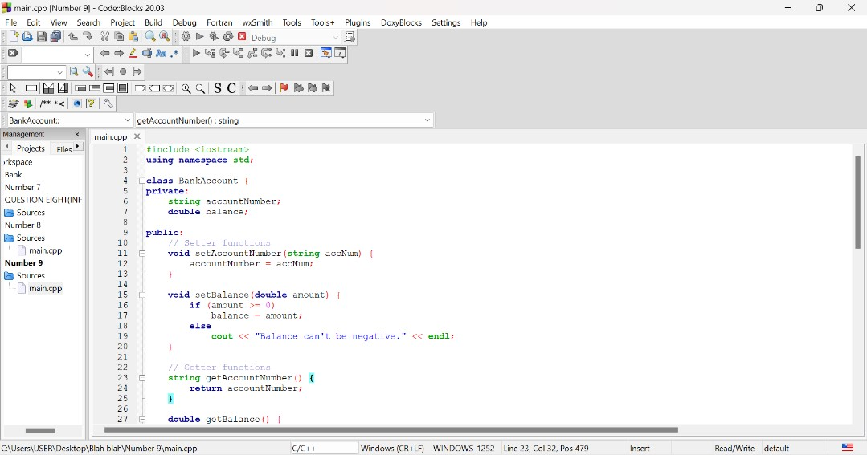
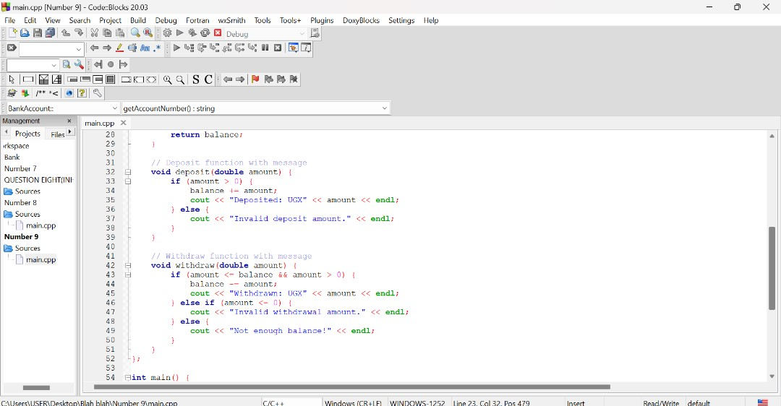
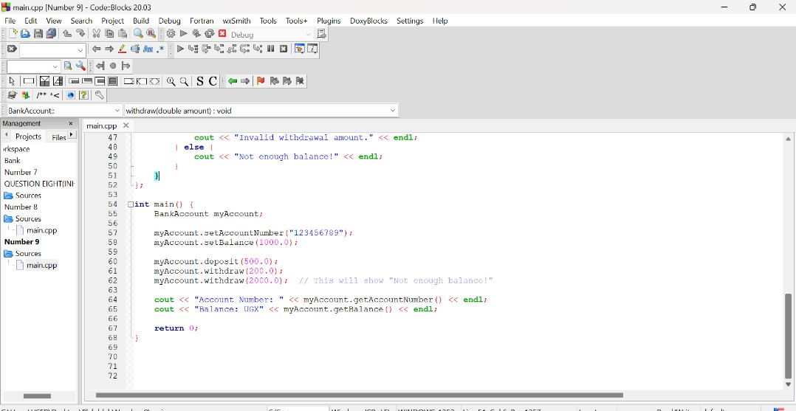

9.3 OUTPUT

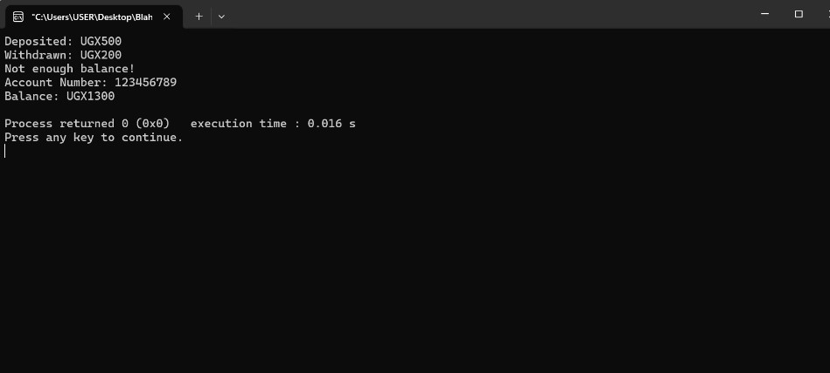

9.4 OUTPUT EXPLANATION
The output reflects successful transactions, blocked invalid ones, and confirms the account’s current state, showing how encapsulation with validation works in action.

QUESTION TEN(FUNCTIONS)
Write a C++ program that demonstrates function overloading using a calculateArea function. The function should be overloaded to calculate the area of different shapes, such as rectangles, triangles, and circles.

10.1 LINES OF CODE & DETAILED EXPLANATIONS

Line Number | Detailed Explanation
#1 | This line includes the input and output library which allows the use of cout for output
#2 | This line allows to use cout without repition of std::
#5 | Defines a function to calculate the area of a rectangle using length * width.
#6 | Calculates and returns the area of the rectangle using the formula:  Area=length×width
#7 | The calculateRectangleArea function ends on this line
#10 | The calculateTriangleArea function with base and height as parameters is declared
#11 | Calculates and returns triangle area using the correct formula:  Area=¹/₂×base×height
#12 | Triangle function ends here
#15 | A function to calculate the area of a circle with radius as input is declared
#16 | Declares a variable pi and sets its value to 3.14159
#17 | Calculates and returns the area using the formula: πrr^2
#18 | The circle function ends here
#20 | This is the start of the main function and where program execution begins.
#21 | This line declares and initializes the length and width for a rectangle.
#22 | This line declares and initializes dimensions for a triangle.
#23 | This line declares and initializes the radius for a circle.
#25 | This calls the rectangle area function and prints the result using cout.
#26 | This calls the triangle area function and prints the result.
#27 | This calls the circle area function and prints the result.
#29 | This line ends the main function and 0 means successful execution.
#30 | This ends the main function

10.2 CODEBLOCKS SCREENSHOTS
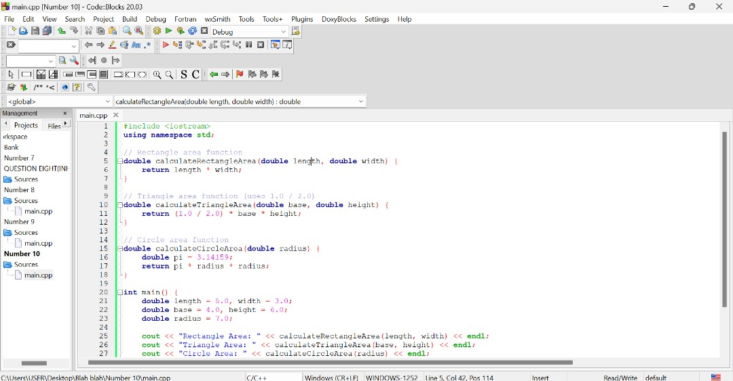

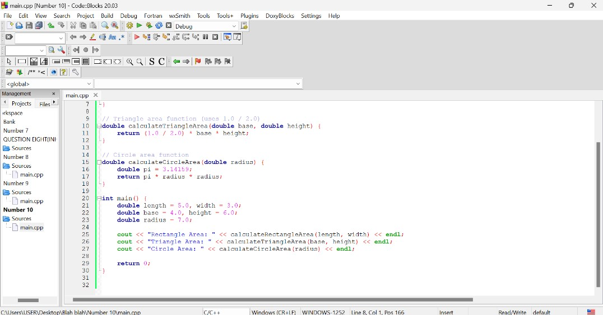

10.3 OUTPUT
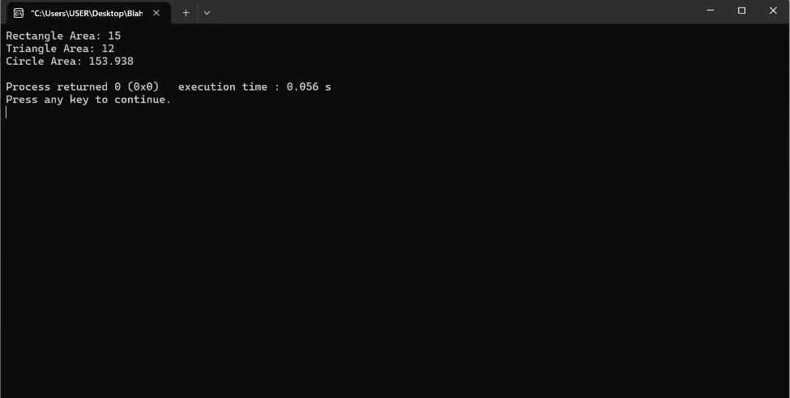

10.4 OUTPUT EXPLANATION
The program calculates and displays the areas of a rectangle, triangle, and circle using predefined values. For the rectangle with a length of 5.0 and width of 3.0, the area is calculated as 15×3=15. The triangle, with a base of 4.0 and height of 6.0, uses the formula ¹ /₂×4×6= 12. The circle has a radius of 7.0, and its area is computed using the formula π×r2=3.14159×49, resulting in approximately 153.938. These calculations are printed to the screen, showing the correct area for each shape based on their respective mathematical formulas.

